PRESS INFORMATION
Elmia AB
April 2011

Ponsse exhibits a harvester that can almost walk on water

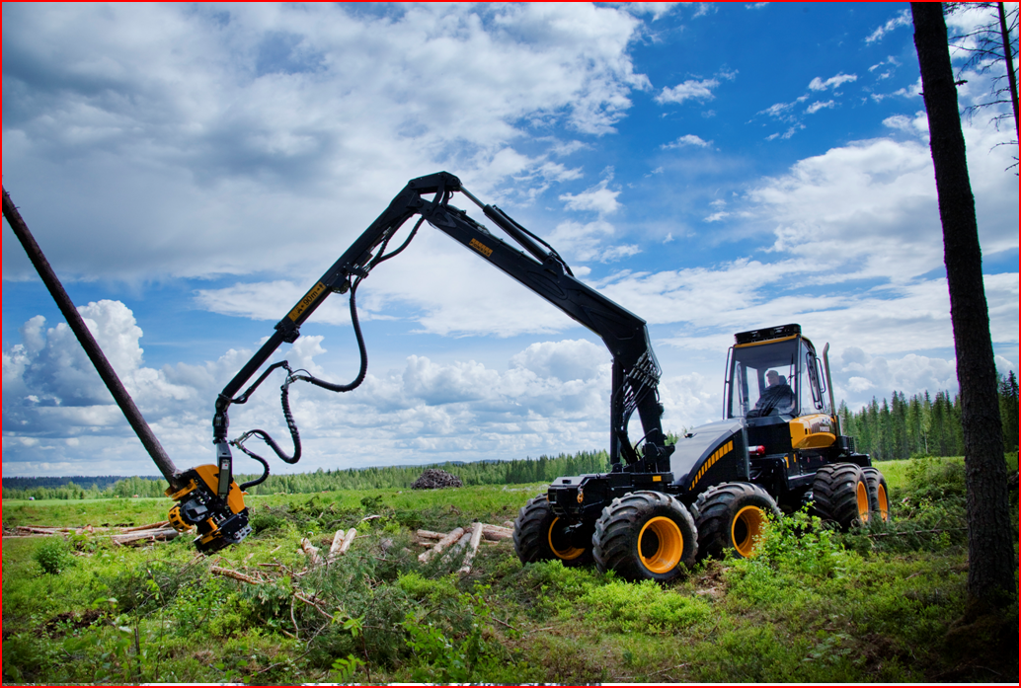
At the top of forest contractors’ wish list is a harvester that can travel across water. Such a thing doesn’t exist but at SkogsElmia machinery manufacturer Ponsse is demonstrating how close we can get with today’s technology.
“We’re exhibiting eight-wheelers in all size categories,” says Jerry Wannberg, the head of Ponsse Sweden.

Eight wheels and articulated frame steering create a flexible and stable machine with high capacity, low ground pressure and excellent operator comfort. With tracks at the back and front plus new cranes, the result isn’t a long way from the ultimate machine of every contractor’s dreams.
“We’ve also focused on reducing diesel consumption and costs,” Jerry adds.

New cranes save fuel
The crane movements of a harvester consume a lot of diesel. Ponsse has invested a lot of resources in making improvements, and all its harvesters now have updated cranes. Two models, Ergo and Bear, have completely new cranes. Both are being shown at SkogsElmia.
“We’re coming to the demo fair with six machines – one machine group in each segment,” Jerry reveals.
Yet another innovation will be sitting at the end of the crane of the new thinning harvester, Fox. This new development is a harvester head designed for efficient multi-stem processing. The head is operated with a new version of the Opti measuring system that makes multi-stem processing even more efficient and gives more reliable measurements.

New equipment for new terrain
Ponsse is also presenting some major innovations on the forwarder front in the form of both updates and new versions. All together, the company’s new machines, cranes, harvester head and measuring system make it well equipped to meet the market’s demands. The increasing demand for timber is leading to a need for machines that can both harvest and forward in terrain previously regarded as too difficult or unprofitable. There is also pent-up demand in Sweden for final felling machines. Many such machines were sold in the country some years ago to clear large areas of forest after two major windstorms and now need to be replaced.
Ponsse is exhibiting its product range at SkogsElmia from 26-28 May.

Caption:
Like Ponsse’s other harvesters, its new Fox thinning harvester has been equipped with an updated crane for lower fuel consumption.

REMINDER:
Planning to attend SkogsElmia? Don’t forget to pre-accredit. If you need help with finding accommodation, please accredit by April 20.
If you already filled out an accreditation form, you will receive your press bagde by post.

