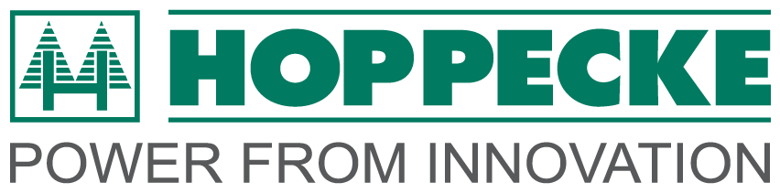 | S H O W P R E V I E W
Ref: PRHP19 Date: 11th January 2011

CeMat, Hannover, 2-6 May 2011: Hoppecke Industrial Batteries
Hoppecke Industrial Batteries – the leading specialist for industrial battery systems and the largest battery manufacturer under European ownership – will have a substantial presence at CeMat where it will display the very latest innovations in battery technology that tie in with the show’s focus on sustainable and innovative products.

Deep in a German forest Hoppecke has one of Europe’s few ‘lead hungry’ smelting plants that incorporates the very latest re-cycling facilities for lead-acid batteries. Bernard Molloy, Managing Director of Hoppecke UK, says: “Our commitment to the environment is firmly part of Hoppecke’s ethos and discovering new, greener technologies is at the heart of our research and development.”

Centre-stage at the show will be the company’s patented trak® air battery system which enables forklift truck fleet owners to slash their carbon footprint while saving thousands on battery replacement costs. At the same time, battery temperature levels are reduced by around 10°C and energy consumption is cut by trak® air reducing the need for battery filling down to four to six times a year, cutting battery gassing and offering over 30 per cent savings on electricity.

Also, charging times are reduced by around 2.5 hours thanks to the trak® air high frequency charger which incorporates a micro-processor. At the same time, water consumption is reduced by up to 70 per cent, giving the batteries a much longer life and minimising the need for battery disposal which is a major environmental headache.

Visitors to the stand will also learn of Hoppecke’s 24 hours a day, seven days a week battery and charger maintenance service that maximises battery availability while at the same time reducing equipment downtime and making sure that battery costs are kept as low as possible. All Hoppecke batteries come with a five year warranty and are backed by the company’s ‘Power for Life’ package in which all battery filling and maintenance as well as testing, installation and inspection are carried out by Hoppecke engineers.

- - - ENDS - - -

Images to support press release:
High resolution images for download:
Image 1: click here
Caption: Bernard Molloy, Managing Director of Hoppecke Industrial Batteries

Image 2: click here
Caption: Hoppecke engineer carrying out battery maintenance

Editor’s Notes

Hoppecke Industrial Batteries Ltd

HOPPECKE was founded in 1927 and is now the leading specialist for industrial battery systems, and at the same time the largest battery manufacturer in European ownership. Hoppecke offers to its customers throughout the world, concepts for efficient and reliable power supply for every industrial application. A leading exponent of environmental care for more than 80 years, Hoppecke offers solutions for a variety of industries including motive power, reserve power for IT/telecoms, power stations, solar energy and UPS, special power for rail and underground. It is a European leader in recycling of industrial batteries, and operates its own recycling foundry for lead-acid batteries, thereby making a substantial contribution to careful husbanding of resources. Hoppecke invests heavily in innovation and has one of the largest R&D departments in the industry with an estimated 5 per cent of turnover being ploughed into R&D to bring new battery technologies to market. Its UK operation is based in Newcastle-Under-Lyme in the Midlands.

Media contact:

Rory Baxter
CHANGEWORKS Communications
t: + 44 (0) 1785 247588
m: + 44(0) 7748 350725
e: rbaxter@changeworkscom.co.uk

Company Contact:

Bernard Molloy
Hoppecke Industrial Batteries Ltd
Unit 2 Lowfield Drive
Centre 500
Wolstanton
Newcastle-under-Lyme
ST5 0UU
T: 01782 667305
W: www.hoppecke.co.uk
E: bernardmolloy@hoppecke.co.uk

