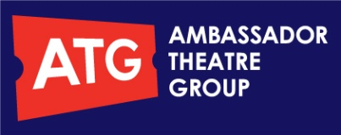

PRESS RELEASE 09.08.10

Mick Perrin for Just For Laughs Live Ltd presents
The Armstrong & Miller Show
Live UK Tour
At The Palace Theatre, Manchester

Following the resounding success of BBC ONE’s BAFTA-winning THE ARMSTRONG & MILLER SHOW, Ben Miller (Moving Wallpaper, The Worst Week Of My Life) and Alexander Armstrong (Mutual Friends) will be hitting the road this autumn with a brand new live show around all the UK’s major venues. Playing two exclusive dates for their first appearance at the Palace Theatre, Manchester on Friday 8th and Saturday 9th October at 8.00pm

With their usual mix of the beautifully observed and the utterly barmy, Ben and Xander will be performing a parade of characters from their extensive dressing-up box and wig-store including; The street-talking WWII chav pilots; Brabbins and Fyffe, the filthy alter-egos of Flanders and Swann; Jilted Jim, dumped at the altar but still on his honeymoon; Terry Devlin, the royal correspondent who really KNOWS the royals; Dennis Lincoln-Park, the accident-prone culture buff; the Frank Dad; and so many more…

Ben and Xander comment: “We are cock-a-hoop to be stepping out on tour in autumn 2010. Expect all your favourite Armstrong and Miller characters and sketches in a market-fresh brand spanking new show.”

“This is mainstream, prime-time sketch comedy as it should be written, superbly performed and shot through with intelligence, invention, silliness and mischief.”
Time Out

Interviews with both Ben and Alexander are available by phone on Friday 20th August from 4.00pm. For further information, competition tickets and images, please contact Andy Longden on 245 6617, Email andylongden@theambassadors.com

- To book tickets call the booking line on 0844 847 2484* or visit www.palaceandoperahouse.org.uk*
- Groups of 10+ Mon-Fri 10am-6pm: 0844 372 7272.
*(subject to booking fee/transaction charge)

