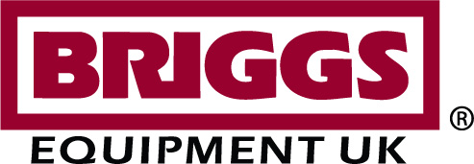

PRESS RELEASE

BRIGGS EQUIPMENT UK Ltd ‘TAKING THINGS TO THE NEXT LEVEL’

Briggs Equipment UK Ltd, a leading national independent service provider and materials handling equipment specialist, has today announced a proposal to start a new working partnership with Yale Materials Handling and is now considering the full alignment of its dealership with the on-going global growth strategy of its parent company – Briggs International Inc.
Briggs International is part of the Sammons Enterprises Inc. equipment distribution division, whose growth strategy is value creation by enabling its materials handling companies to share talent and best practices. Companies within the equipment distribution division include: Briggs Equipment Mexico and Briggs Equipment US, who are already major distributors of Yale Materials Handling products.
“Having grown the Briggs Equipment brand into a UK success story, it is only right and proper, that we now consider strategically aligning ourselves with the other members of the Sammons equipment distribution division by becoming the distributor of Yale Materials Handling in Great Britain.

“In these difficult times, it is now particularly necessary for our organisation to review our growth strategy.” commented Chief Executive Officer, Richard Close.

A seamless change
Briggs Equipment will continue to support all its customers throughout this period of realignment.

“We are confident that all our customers will experience a totally seamless and smooth transition throughout this period, as our ultimate objective is to benefit our customers both now and in the future,” added Richard Close.

Over 20 years of experience in materials handling equipment
Briggs Equipment UK Ltd proposes to become the sole national distributor of Yale Materials Handling equipment in Great Britain, providing a comprehensive range of equipment for all materials handling applications. With headquarters in Cannock, England, Briggs is committed to becoming the customer’s first choice service provider, providing the right products, service, support and advice to keep customers moving safely and productively.

- - - ENDS - - -

Editor’s Notes

Briggs Equipment UK
Briggs Equipment UK Ltd is a leading materials handling service provider. Proving a wide range of equipment for a broad customer base, Briggs provides innovative, tailored and cost effective solutions on a nationwide basis. With its headquarters and national support centre in Cannock, Briggs people assist and advise in the delivery of long term solutions that enable customers to develop more efficient and results driven businesses.

View all of Briggs Equipment’s latest news on the Briggs online media centre.

Media contact:

Sue Tupling
CHANGEWORKS Communications
t: + 44 (0) 1785 247588
M : 07703023026
e: sue@changeworkscom.co.uk

Company Contact:

Scott Bullock
Briggs Equipment
Orbital Way
Cannock
WS11 8XW
T: 01543 430 455
W: www.briggsequipment.co.uk
E: scott.bullock@briggsequipment.co.uk

